Community AV Archiving Fair (AV Fair)
Welcome Packet
http://communityarchiving.org/avfair

Basic Info
Saturday, December 1, 2018
10am-4pm
Hilton Portland Downtown
921 SW 6th Ave, Portland, OR 97204

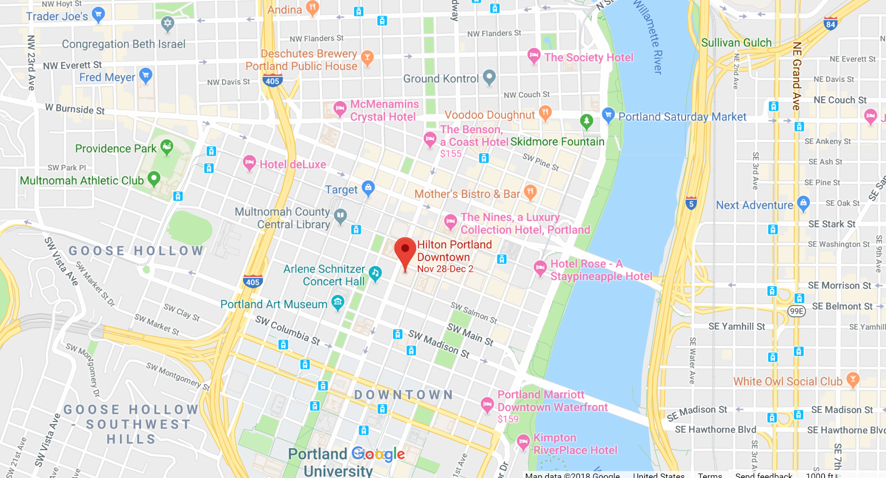

Contact Information
communityarchivingworkshop@gmail.com

Social Media
Facebook: @communityarchivingworkshop
Instagram: @cawworkshop
Twitter: @CAWworkshop
#communityarchivingworkshop
#AMIA18
#avfairPDX
#archivesinthewild

Parking Options
There are two SmartPark locations close to the hotel:
SmartPark  730 SW 10th Ave, Portland, OR 97205 | SmartPark 4th & Yamhill  818 SW 4th Ave, Portland, OR 97204
Open 24 hours
Weekend Parking Rates: $5 all day
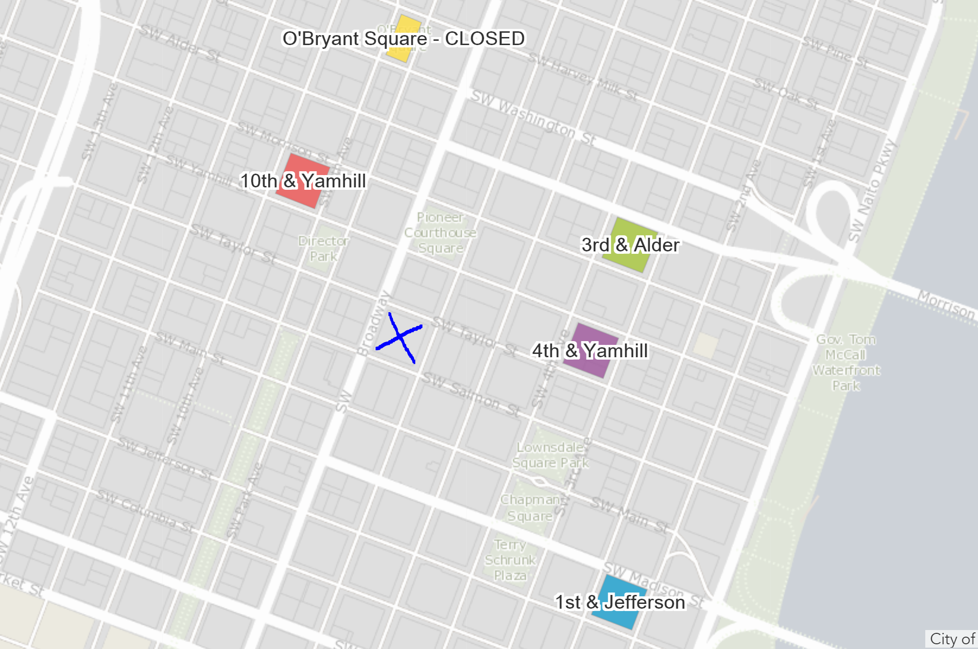

Collection & Equipment Drop-off
If you need to drop off collection materials before you park, you can pull in front of the hotel on SW 6th Ave. There will be volunteers available to guard your items in the hotel lobby while you park.

Getting to the AV Fair in the Hotel
The AV Fair is located in the Grand Ballroom of the hotel, one level down from the lobby. You can go directly to the lobby elevator and down one level, and it will be straight back as you exit the elevator.

Featured Collection: KBOO
The KBOO Archive chronicles the activist, countercultural and musical connections of the Pacific Northwest. KBOO’s focus on unrepresented viewpoints increases empowerment, visibility, and accessibility for communities, movements, and figures working to create a better world. As a result, KBOO has nearly 50 years of materials, both audio and video, that document the countercultural life of the Pacific Northwest, with Oregon in the center.

KBOO has over 7,500 locally-produced interviews, reports, and performances — all high-risk assets that represent unique Oregonian voices and perspectives.

In 2016, KBOO started preserving 50 years of historic audio from ¼” open reel tape to digital format, cataloging them, and making them accessible online. KBOO is committed to protecting & sharing this important part of Oregon’s heritage: a singular collection from a singular Oregonian institution that represents the best goals of the original FCC vision for US broadcasting. Oregon has a long tradition of civic engagement, creativity, and activism from which to gain a more complete understanding of Oregonian culture.

Welcome and Station Matching
Sign in at the Welcome station.

Stations to Visit
- Welcome and Station Matchmaking (W)
- KBOO Collection (KBOO)
- Audio Digitization (AD)
- Film Inspection (FI)
- Analog Inventory Techniques (AIT)
- Prioritizing & Preparing Media for Digitization (PMD)
- Video Digitization (VD)
- Film Digitization (FD)
- Digital Preservation & File Storage Management (DP)
- Disaster Preparedness & Recovery (DPR)

Welcome and Station Matchmaking (W)
Format: One-hour shifts
Description: Please sign in at the Welcome desk so we know you’re here. Not sure where you’d like to start? Tell us what your needs or interests are and we’ll recommend a station for you to visit. Are the AV materials you’re bringing really heavy? We can help you carry them to the appropriate station.
Intended audience: Anyone who isn’t sure where to start
Bring with you: Nothing required.

KBOO Archive (KBOO)
Format: Hands-on, discussion (all day)
Description: This station seeks to empower community members to preserve and provide access to a sample of ~200 ¼” open reel audio tapes from the KBOO Archive. Along with KBOO volunteers, attendees will create a simple inventory that includes condition notes based upon the Archive’s catalog, using Google Sheets / Excel / Google Forms. The KBOO Archive station will provide basic descriptive metadata and guidelines; rehousing and labeling if needed; prepare tapes for digitization at the nearby Audio Digitization station; and will fine-tune procedures that will help complete the project beyond the AV Fair.
Intended audience: Anyone who is interested in KBOO’s history, and anyone that would like to learn more about inspection, handling, and preparation for digitization of ¼” open reel audio.
Bring with you: Nothing required, but attendees are encouraged to bring laptops for cataloging.

Audio Digitization (AD)
Format: Hands-on, demonstration and discussion (all day)
Description: This station is dedicated to digitizing a selection of ¼” open reel audiotapes from the KBOO Archive. Attendees will learn steps to preparing tapes for digitization, including preservation assessment, attaching leaders, and tape repacking, and will help digitize tapes using a basic digitization setup using TEAC decks, Prism Titan A/D converter, Audacity, and BWF MetaEdit.
Thank you Nathan Georgitis, University of Oregon, and Association for Recorded Sound Collections for volunteering your time and equipment!
Intended audience: Anyone who is interested in KBOO’s history, and anyone who would like to learn more about digitization of ¼” open reel audiotape.
Bring with you: Nothing required.

Film Inspection (FI)
Format: One-on-one or small group demo and discussion (~20 min)
Description: Attendees will learn how to determine basic information about a film without having to watch it, and will learn how to answer questions such as: Does it have sound? Is it color or b/w? What is the title? How do you read date codes?, etc. Depending on the needs of each attendee, station volunteers will go into greater detail and provide recommendations on equipment, and/or provide hands-on training on topics such as how to add leader and how to splice film.
Intended audience: Anyone with film that would like to learn more about inspection and handling
Bring with you: Nothing required, but attendees are encouraged to bring a small selection of films (1-2) to be inspected.

Analog Inventory Techniques (AIT)
Format: Hands-on and small group lecture (~20-30 min)
Description: AMIA volunteers will provide a hands-on demonstration on how to identify common magnetic media and film formats (as needed), then show attendees how to create a simple inventory template using Google Sheets / Excel / Google Forms which provides essential data about the collection for use in collection planning and advocacy.
Intended audience: Archivists / Artists with an unprocessed av collection; those looking to improve organization and physical order of their collections; those looking to establish a cataloging workflow; those looking to gather data about their collections for advocacy or grant-funding.
Bring with you: Attendees are encouraged to bring sample items (5-25) from their collection to test and inventory, laptops for cataloging, and are encouraged to bring in any existing inventory strategies for discussion and review.

Prioritizing & Preparing Media for Digitization (PMD)
Format: Small group (max 10 people) discussion (~20-30 min)
Description: This is a good station to go to after the Analog Inventory Techniques station. Attendees will learn considerations for prioritizing media for digitization, and methods for preparing media for digitization. We will discuss assessing the value of media based on personal or organization needs, with the ultimate goal of establishing concrete prioritization tiers. We will also discuss manageable preparation work for physical media (film + video), including basic storage concerns and long term planning. Digitization is not a quick fix or “one and done” process. Preparation and prioritization will help in managing time, resources, and expectations.
Intended audience: Filmmakers, personal archivists, curious individuals – anyone embarking on a smaller-scale media digitization project for the first time (and with minimal resources).
Bring with you: Attendees are encouraged to bring in any existing inventory strategies for discussion and review, along with sample items (5-25) from their collection to assess.

Video Digitization (VD)
Format: Small group (5 persons max) hands-on demonstration (~20 min)
Description: Attendees will learn about a basic digitization setup for analog video which can be implemented at low-cost, and with minimum equipment needed to perform good quality video digitization in house and will get acquainted with signal paths, connectors and video digitization workflows. Each demo session covers:
1. Video and audio signal paths
2. Wiring diagrams for audio and video
3. Common cables and connectors
4. Minimum equipment for good quality digitization
5. Discussion on target formats
6. Digitization software
7. Additional useful tools (if there’s enough time)
Intended audience: People from small/community orgs with video collections and reduced budget
Bring with you: Nothing required, but attendees can bring VHS tapes to be transferred

Film Digitization
Format: Small group (5 persons max) hands-on demonstrations (~20 min)
Description: Attendees will learn about a basic digitization setup for film.
Intended audience: People from small/community organizations with film collections and reduced budget
Bring with you: Nothing required, but attendees can bring 1-2 short film reels to be transferred if possible (30 min of content maximum per attendee).

Digital Preservation & File Storage Management (DP)
Format: One-on-one and small group consultations (~ 30 min)
Description: This station offers practical tools and strategies to begin preserving your digital materials. Discover what’s on that mystery hard drive, DVD, or floppy disk. Learn how to build your own digital forensics station.
Intended audience: Attendees interested in learning more about the best practices, tools, and strategies for preserving your digital materials.
Bring with you: Nothing required, but sample digital materials or digital media mysteries in your collection are welcomed, like hard drives, flash drives, CDs, DVDs, 3.5 floppies, and questions.

Disaster Preparedness & Recovery (DPR)
Format: Exhibit, Q&A
Description: The aim of this station is to introduce attendees to approaches for how to mitigate disasters, how to be prepared when disaster strikes, how to respond in an emergency, and how to assess and salvage damaged audiovisual items.
Intended audience: Attendees interested in learning more about disaster preparedness and recovery.
Bring with you: Nothing required.

Resources
Community Archiving Workshop Handbook
http://communityarchiving.org/
Guide to producing your own Community Archiving Workshop (in progress).

AMIA General Resources
https://amianet.org/resources/general-resources/
List of useful links to report, guides, blogs and podcasts, conferences, webinars and other resources compiled by the AMIA Education Committee.

AMIA Listserv
https://amianet.org/engage/amia-l-listserv/
Open to the public, this listserv is a lively forum for discussions and questions about topics relating to audio-visual archiving.

CAVPP Audiovisual formats guide
https://calpreservation.org/wp-content/uploads/2013/10/2013-Audiovisual-Formats_draft_webversion-2013oct15.pdf
A printable .pdf for the vaults and on-the-go. Includes pictures and definitions for audio, video and film formats, signs of active deterioration and damage, as well as tips for long-term storage.

The American Institute for Conservation of Historic and Artistic Works (AIC)
http://www.conservation-wiki.com/wiki/Electronic_Media

AUDIO CARE AND STORAGE
Association of Recorded Sound Collections (ARSC)
http://www.arsc-audio.org/index.php
Founded in 1966, the Association for Recorded Sound Collections (ARSC) is a nonprofit organization dedicated to research, study, publication, and information exchange surrounding all aspects of recordings and recorded sound.

The Care and Handling of Recorded Sound Materials
http://cool.conservation-us.org/byauth/st-laurent/care.html
Describes the basics of recording sound and outlines some degradation risks and preservation procedures for various sound formats.

FILM CARE AND STORAGE
Film Forever: The Home Film Preservation Guide
http://www.filmforever.org
Easy-to-follow guide sponsored by the Association of Moving Image Archivists
Little Film
http://www.littlefilm.org/
Information about 8mm, Super-8mm, 9.5mm and 16mm film (the common home movie formats).
The National Film Preservation Foundation Film Preservation Guide
http://www.filmpreservation.org/preservation-basics/the-film-preservation-guide

Washington State Film Preservation Manual
http://www.lib.washington.edu/specialcollections/film-preservation-manual/at_download/file
Low-cost and no-cost suggestions about how to care for your film. This manual includes information about how to identify what you have and what to do with it.

VIDEOTAPE CARE AND STORAGE

AIC: Electronic Media Group
http://cool.conservation-us.org/coolaic/sg/emg/index.html
The Electronic Media Group, formed in 1998, is a subsidiary of the American Institute for Conservation of Historic and Artistic Works (AIC), a professional membership organization for conservators.

Bay Area Video Coalition (BAVC)
http://www.bavc.org/preservation
BAVC’s works with museums, independent artists/ mediamakers and cultural institutions around the world to remaster, transfer, and archive seminal creative and historical works on video and audio tape.

Specs Bros.
http://www.specsbros.com/
Includes information on disaster planning for tapes.

Texas Commission on the Arts Videotape Identification and Assessment Guide
http://www.arts.texas.gov/video/
This online guide was created by the Texas Commission on the Arts to assist custodians of video materials with the care and preservation of these materials.

Video History Project
http://www.experimentaltvcenter.org/history/resources.html
Research initiative that documents video art and community television as it evolved in rural and urban New York State, and across the U.S.

OPTICAL MEDIA

An Introduction to Optical Media Preservation
http://www.avpreserve.com/wp-content/uploads/2014/04/OpticalMediaPreservation.pdf

Care and Handling of CDs and DVDs: A Guide for Librarians and Archivists
http://www.clir.org/pubs/abstract/pub121abst.html

Map
Map may change. Please visit the Welcome Station for the most current station locations.

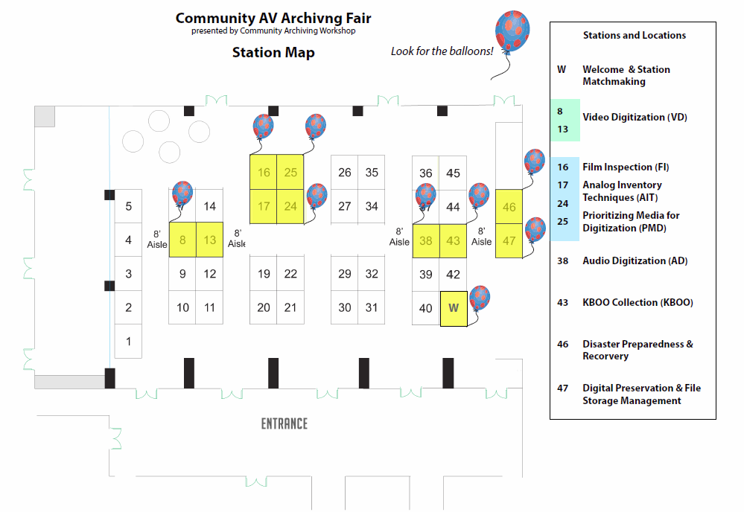

Give Us Some Feedback!
Let us know how you liked the AV Fair! You can fill out this form and leave it at the Welcome Station or any other station.

What did you like about the AV Fair?

What would you like to see improved for the next AV Fair?

Do you have any general comments about the AV Fair?

Your Calling Cards
Fill out and leave at any stations where you would like more information sent to you.

Station Name________________  _____________________________________  Name  _____________________________________  Email  _____________________________________  Organization | Station Name________________  _____________________________________  Name  _____________________________________  Email  _____________________________________  Organization
Station Name________________  _____________________________________  Name  _____________________________________  Email  _____________________________________  Organization | Station Name________________  _____________________________________  Name  _____________________________________  Email  _____________________________________  Organization
Station Name________________  _____________________________________  Name  _____________________________________  Email  _____________________________________  Organization | Station Name________________  _____________________________________  Name  _____________________________________  Email  _____________________________________  Organization
Station Name________________  _____________________________________  Name  _____________________________________  Email  _____________________________________  Organization | Station Name________________  _____________________________________  Name  _____________________________________  Email  _____________________________________  Organization
Station Name________________  _____________________________________  Name  _____________________________________  Email  _____________________________________  Organization | Station Name________________  _____________________________________  Name  _____________________________________  Email  _____________________________________  Organization

